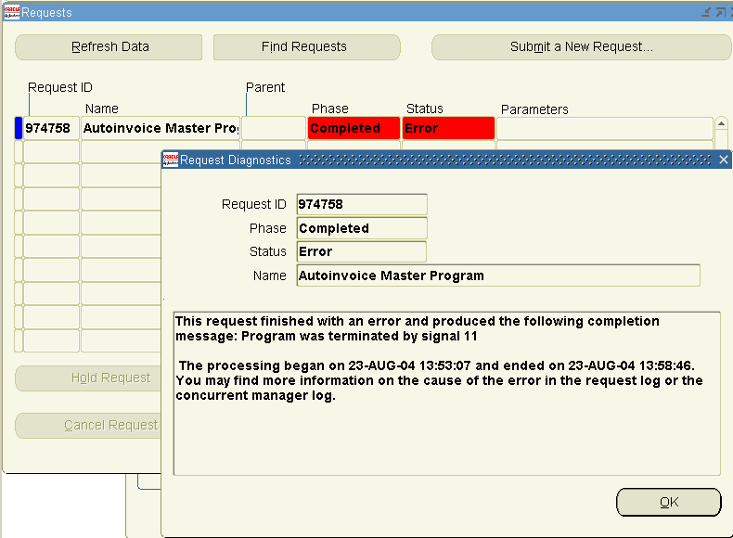

----- check out REQUEST_ID not null, to make them null to be able to import into AR
----Harris

select *
from apps.ra_interface_lines_all
WHERE nvl(interface_status,'x') != 'P' and REQUEST_ID is not null;

select INTERFACE_LINE_ATTRIBUTE1,interface_line_id,customer_trx_id,request_id, link_to_line_id
from apps.ra_interface_lines_all
WHERE nvl(interface_status,'x') != 'P' and REQUEST_ID is not null;

UPDATE ra_interface_lines_all
SET interface_line_id = null,
customer_trx_id = null,
request_id = null,
link_to_line_id = null
WHERE nvl(interface_status,'x') != 'P' and REQUEST_ID is not null;

